2022

LAUTOKA HOSPITAL DENTAL DEPARTMENT

WORLD ORAL HEALTH DAY
&
NATIONAL ORAL HEALTH WEEK REPORT

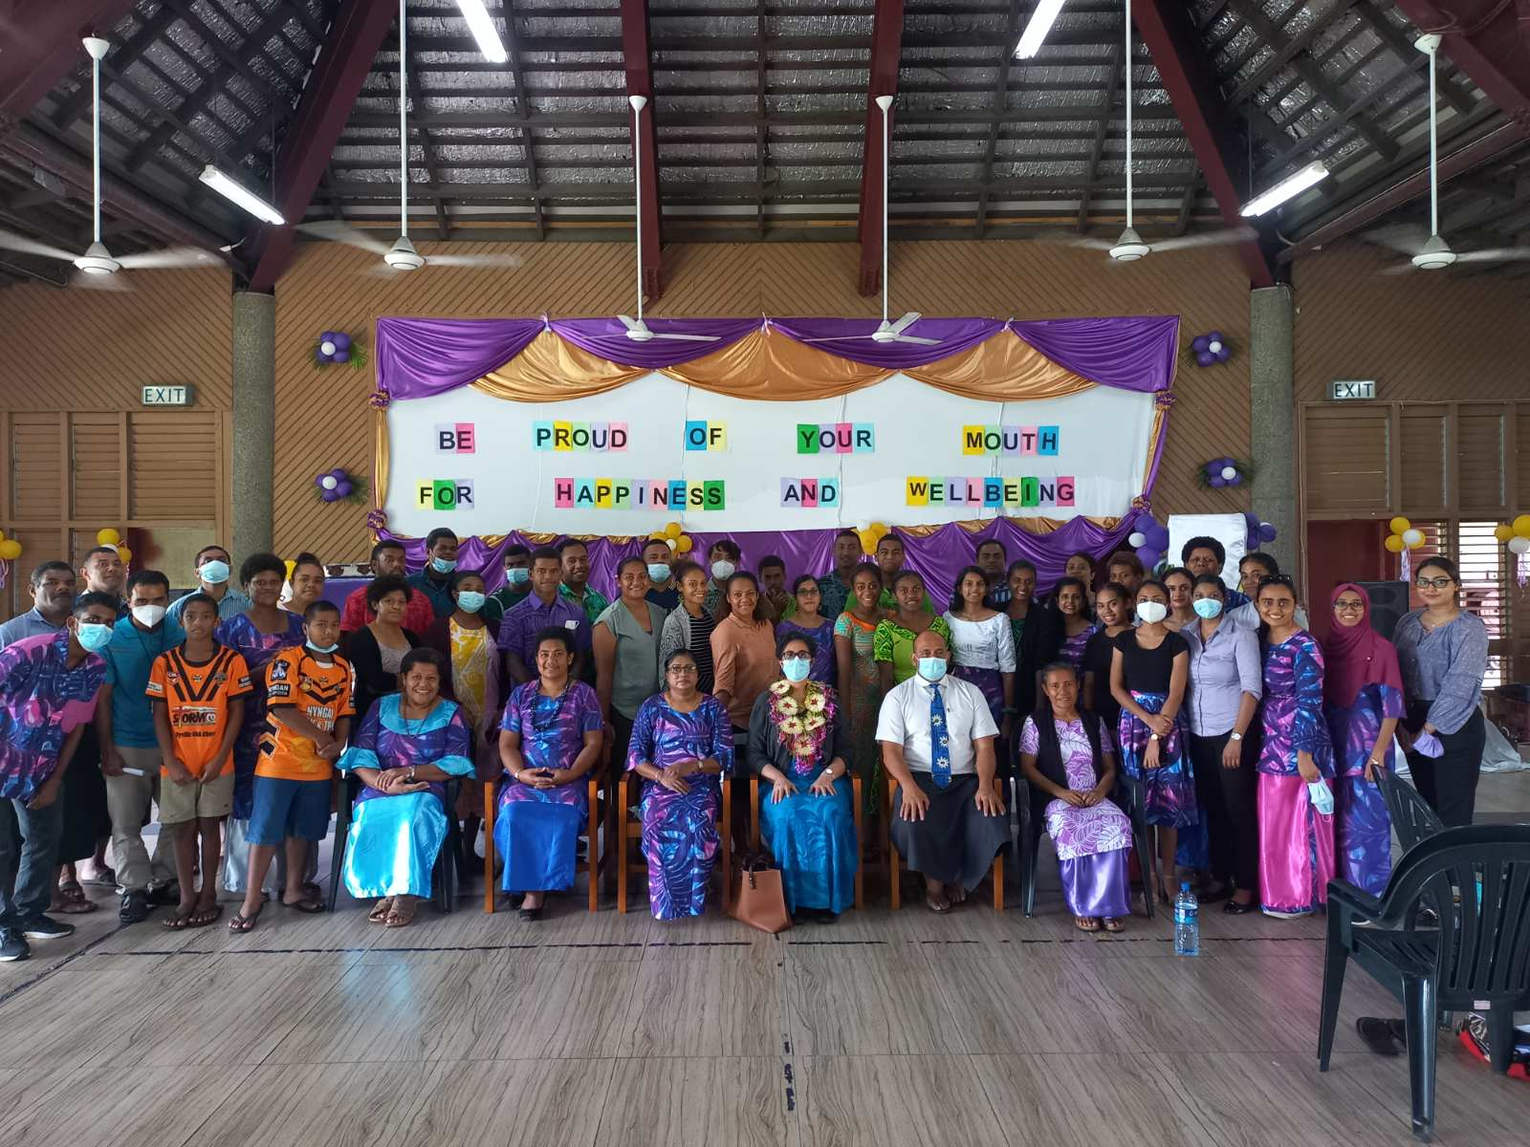
20/03/22- 25/03/22

Introduction
The World Oral Health Day and National Oral Health Week celebrations were carried out successfully as planned from the 20th to the 25th of March, 2022.
The Oral health team together with our stakeholders Faith based organization; SDA youths were part of the World Oral Health Day celebration which was officiated by the Medical Superintendent of Lautoka Hospital, Dr Rigamoto Taito.
The unexpected change of weather condition a few days before the celebration did not deter the spirit within the team and we are grateful to all those that turned up for the day. Though turnout was only 65%, response was very encouraging. This was evident from participants input in the evaluation questionnaire.
The program was execute well with Oral Health messages delivered. The womb to tomb concept was highlighted to our targeted audience; youths as they are future parents. With the basic knowledge, they will be able to impart what they have learnt to their children, peers and communities.
Tooth development starts during the 6th week of pregnancy. Proper nutrition and oral health care for expected mothers during the 9 months will determine the unborn baby’s developing dentition and wellbeing.
Caries rate amongst the 5 year old is above 70%. There is a need to re-orientate Oral Health Promotion messages in a holistic approach so that individuals can understand the importance of oral health care.
The Dental Department in Lautoka Hospital is embarking to focus on ANC and MCH at Post natal ward before mothers are discharged. The World Oral Health Day celebration provides a suitable platform to disseminate Oral Health Wellness information. A booklet had been designed to be given to all mothers at Post natal ward to use as a guide in monitoring their child’s tooth eruption dates and care with emphasis on the 8 wellness visits.
Evaluation questionnaire issued to randomly selected participants show that 31% understand the importance of tooth brushing before bedtime and when to start oral health care.

Objective
Objectives were met during the one (1) week program as mentioned below:
- Successful completion of Oral Health programs -World Oral Health Day and National Oral Health Week
- Strengthen Private Public Partnership and networking – Ministry of Youth and Sports/ Faith based organization
- Participants desiring more awareness programs at all level in the communities as they now understood tooth development starts in the womb and importance of maintaining good oral health for better general health.
Achievement
- Business Plan Priority Area Targeted
Priority Area 1: Reduce communicable disease and non-communicable disease prevalence, especially for vulnerable groups
Objective 1.1
Preventative programmes targeting risk factors implemented
Objective 1.2
Improve the physical and mental well-being of all citizens, with particular focus on women, children and young people through prevention measures
- Lautoka Hospital Dental Department Business Plan Reference:

- Objective 1.1.1 Preventative programs targeting risk factors implemented

- Objective 1.1.2 Strengthen the integrated approach to preventive initiatives in communities through multidisciplinary teams

Acknowledgement:
The Oral Health Team would like to thank all who have contibuted, assisted the team to complete the week long program successfully:
- Ministry of Health and Medical Services – For approving funds for the Oral Health Promotion program
- Head of Wellness – For support and endorsement for allocation to source funds for the Oral Health Promotion activities
- SAO HQ – For Assistance and guidance in compiling all necessary documents
- The Medical Superintendent Lautoka Hospital – For her support and being Chief guest for World Oral Health Day 2022
- Ministry of Youth & Sports Lautoka office – For Liaising with youth groups for Oral Health awareness sessions in their communities
- Colgate – For the supplies of toothbrush packs for all Oral Health awareness participants
- Private Dental Practitioners- Donations that enabled the purchase of bottled Water and Fruits for refreshments
- SDA Pastors, Youths – participants for World Oral Health Day celebration
- Naviyago village, Lovu Hart, Koroipita youths and liaising officers – Our target population for the Oral Health awareness
- PDO & SDO – Support and assistance with organizing staff rotation and program
- Dental Staff and families – Assistance with venue decorations and set up
- Oral Health Outreach team– For Oral Health Promotion and visual dental-checkup
- Drivers– for transportation
Thank you all for the tremendous support and team work

WORLD ORAL HEALTH DAY CELEBRATION -20/03/22
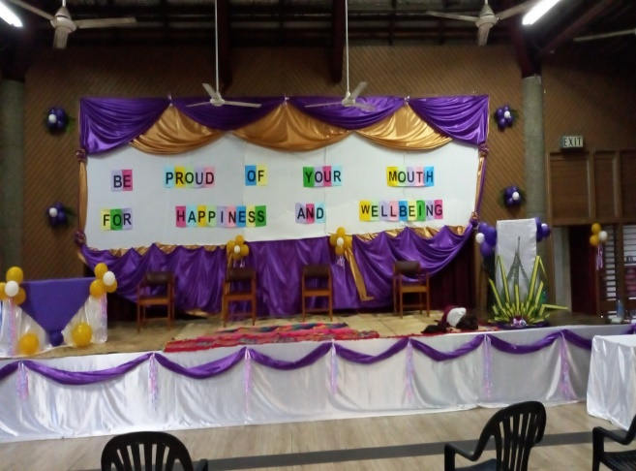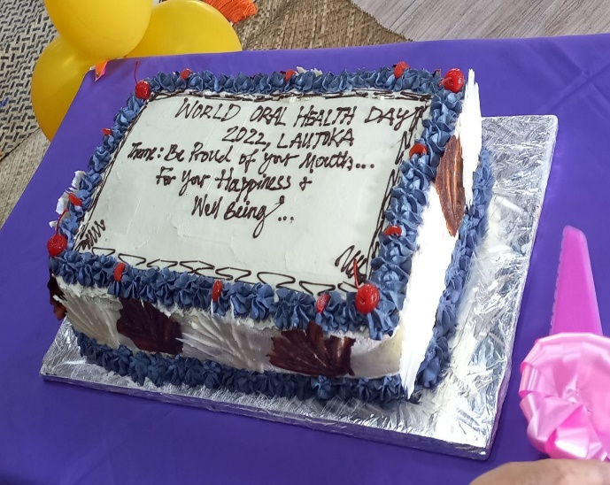
Venue Decoration at Girmit Center World Oral Health Day Celebration Cake

Display Booth – Oral Health Educational materials and photo booth
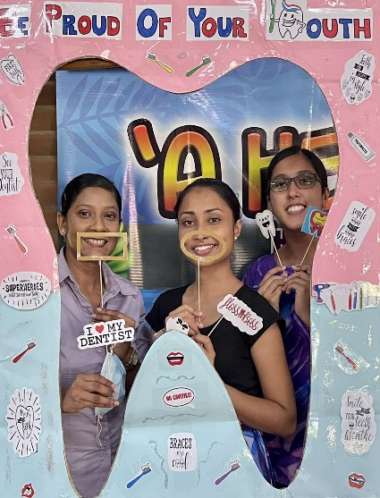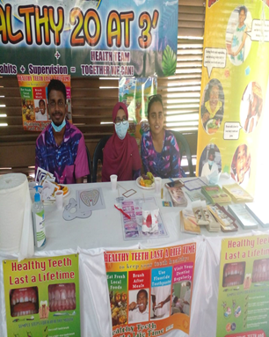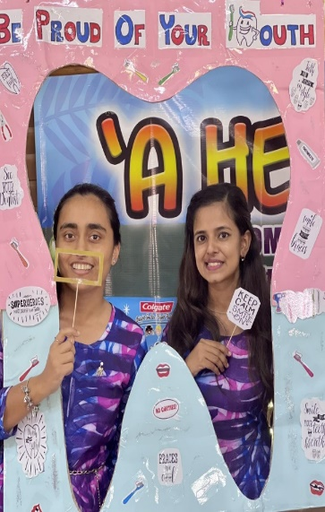

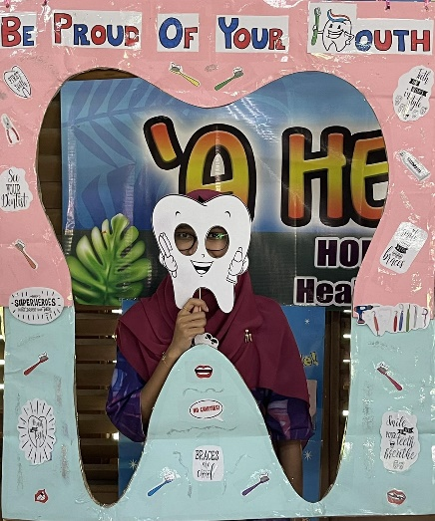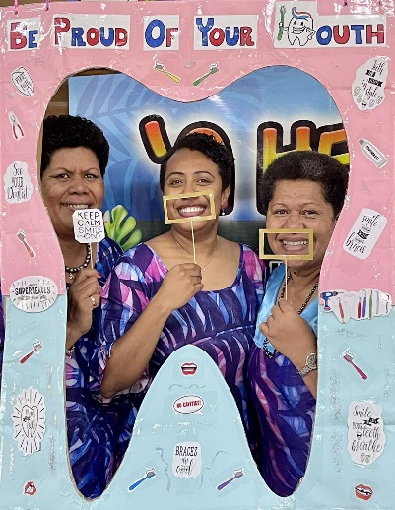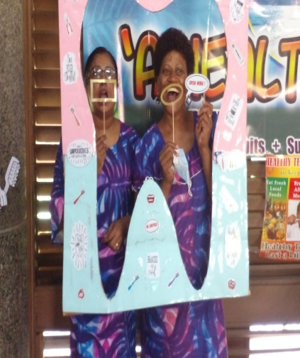

World Oral Health Day Program
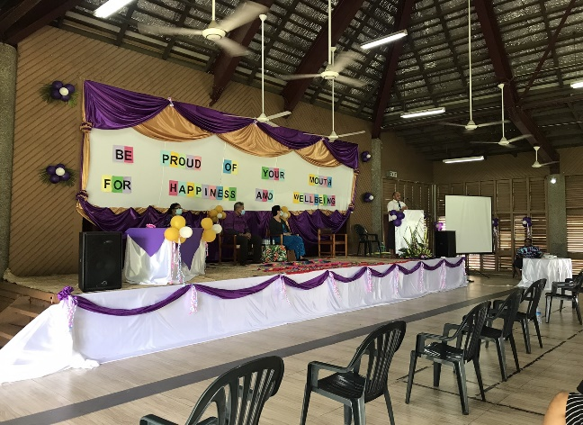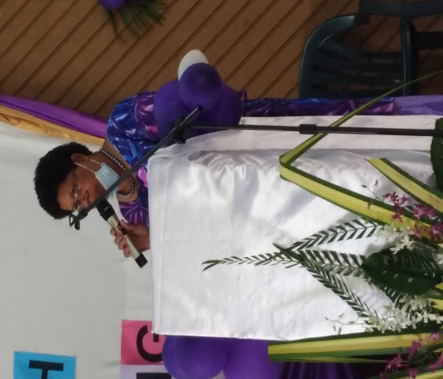
Pastor Albert conducting devotion Introduction of Chief Guest by IDT Mrs Korovou
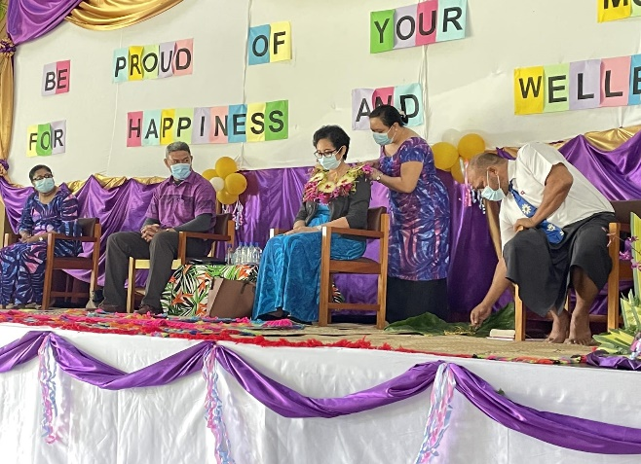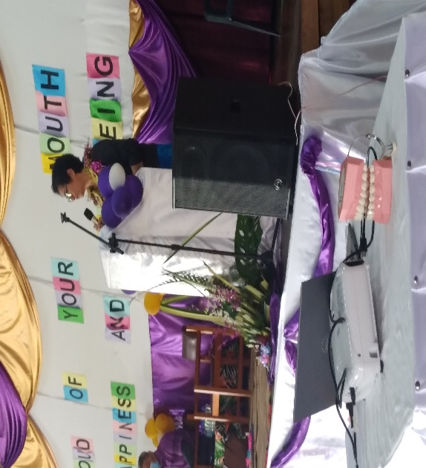
Garlanding of Chief Guest by Dr Rejieli Dr Rigamoto delivering her speech
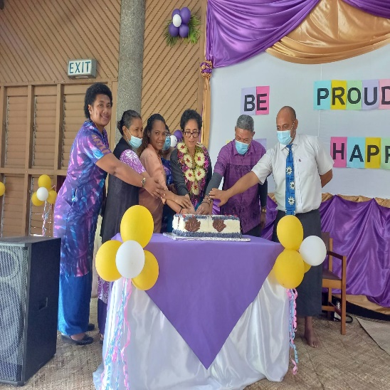 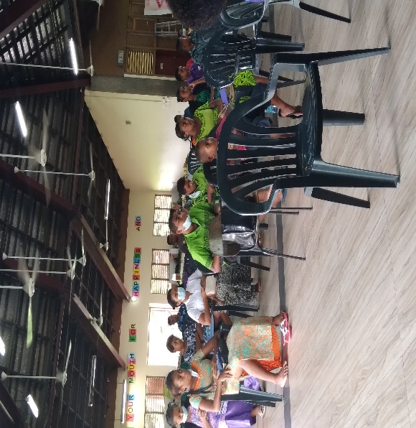Participants SDA youth
Cutting of the World Oral Health Celebration Cake
Together We Can…Matron Maternity, NCD officer SDA , Youth Representative, PDO Lautoka Dental, Chief Guest Dr Taito, Hospital Administrator & Pastor Albert

Refreshments

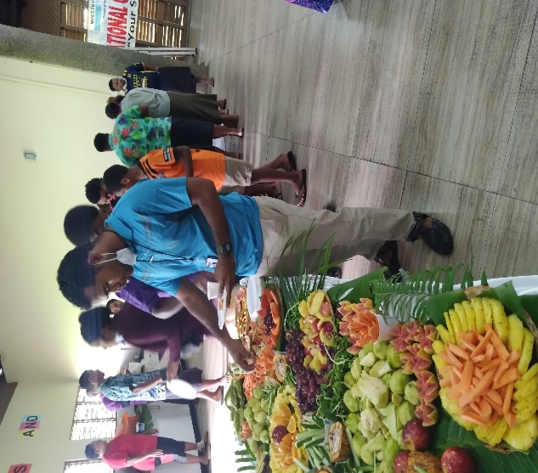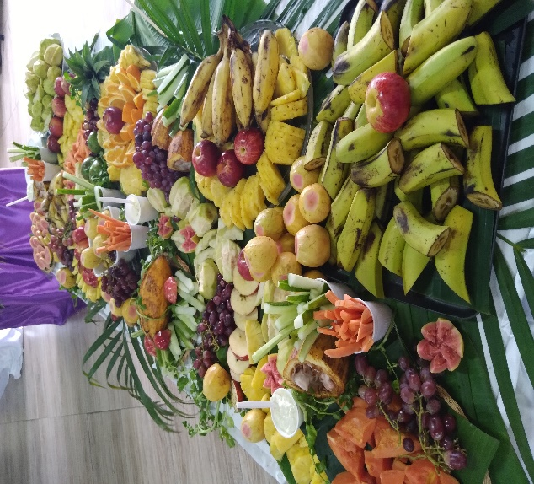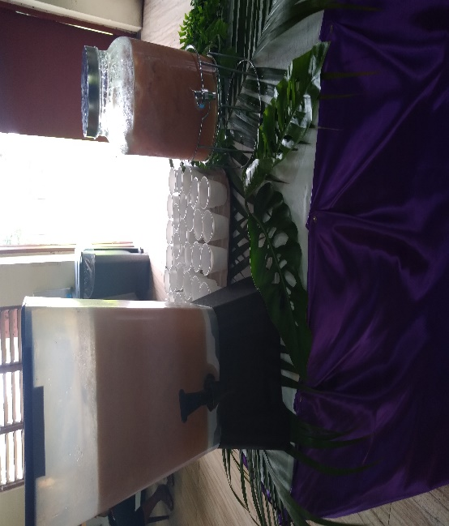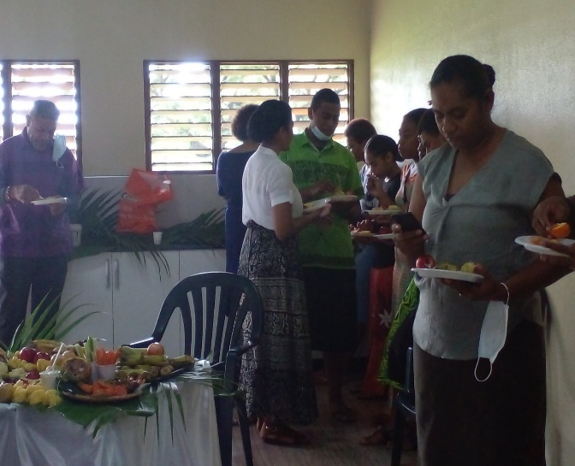
Participants treated to refreshments prepared by staff
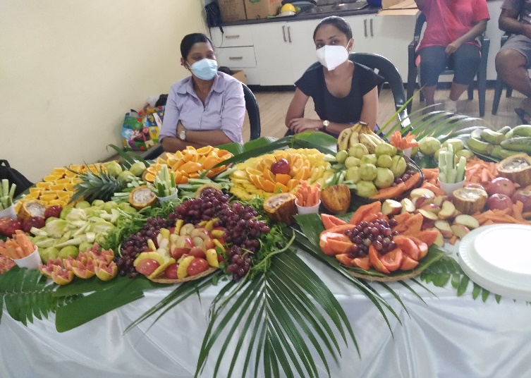

Presentations
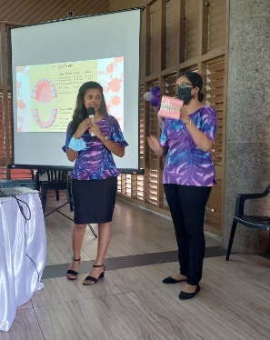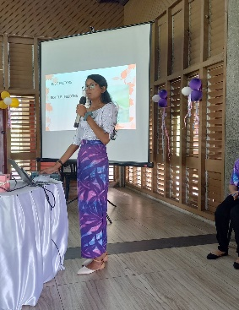
Dr Simran…Tooth development Dr Devashna… Risk Factors and Childhood caries
and Eruption sequence
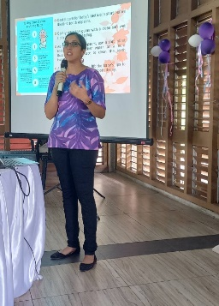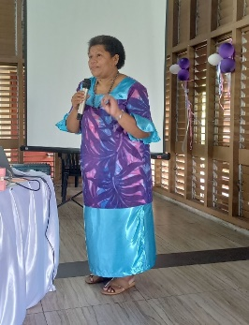
Dr Nida…Teething and Oral health care IDT Tuiloma… Oral Health Wellnes & Focusing on ANC &
MCH for Happiness and Wellbeing

Colgate Packs
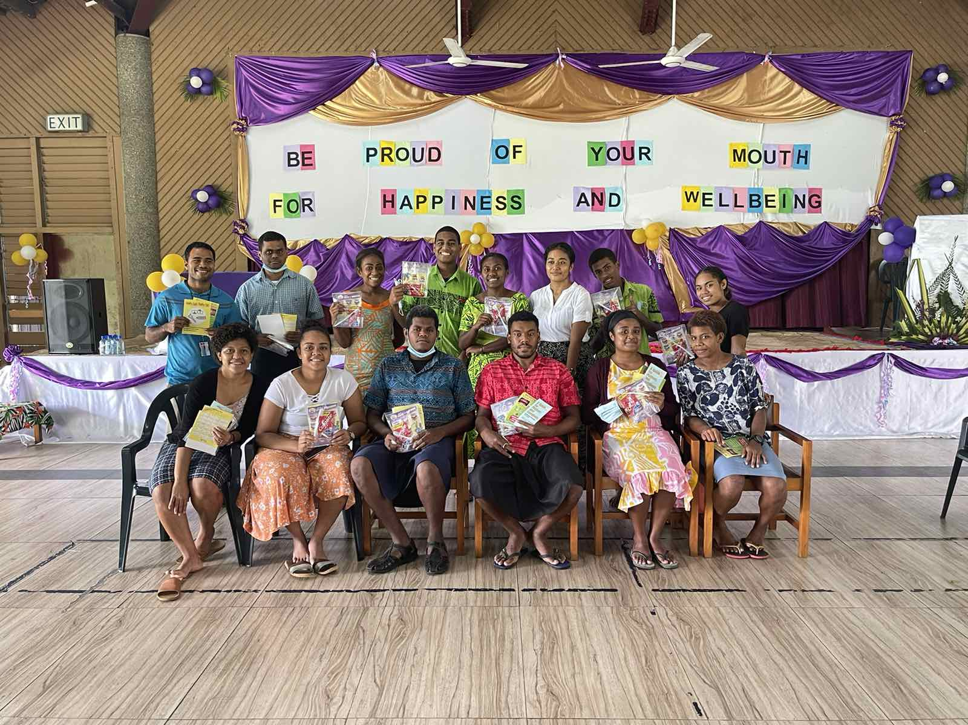Some of the participants with their Colgate packs
Lunch
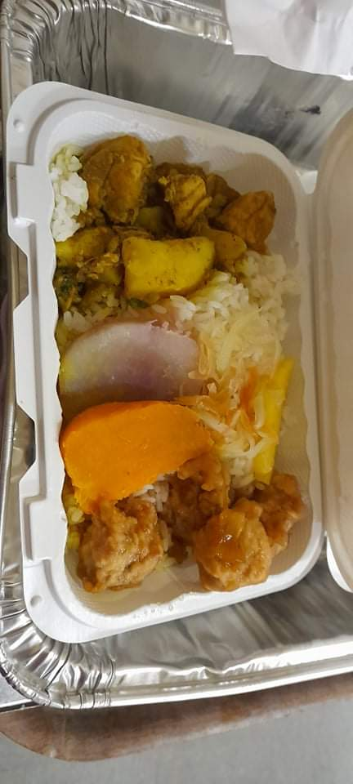 Lunch packs of sweet & sour fish, chicken curry, pawpaw salad,rice and sweet potatoes

Support
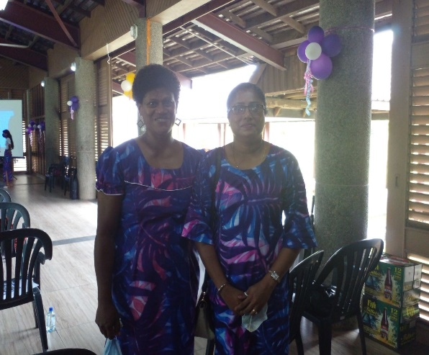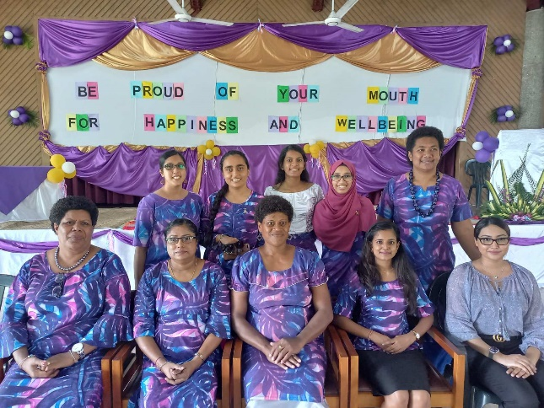
PDO Dr Pravina Singh & SDO Clinical Dr Janette Dental ladies & Matron Luisa (Maternity)
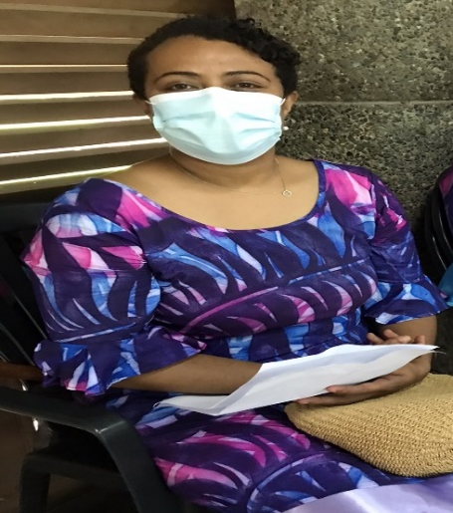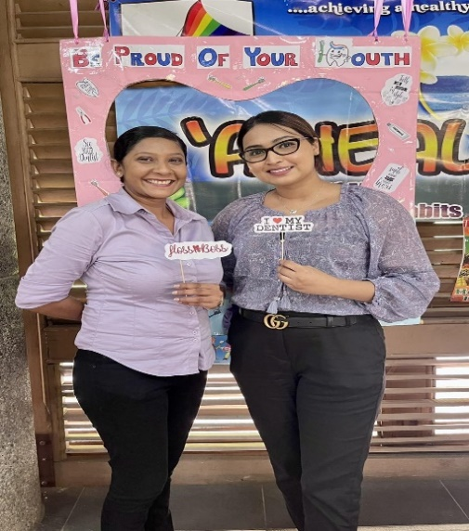
Dr Venina Padmini & Dr Kulsoom

NATIONAL ORAL HEALTH WEEK – (21/03/22-25/03/22)
The National Oral Health Week was celebrated with organized Oral Health Awareness sessions to three (3) youth groups in Lautoka.
The youth groups were engaged through the assistance of Ministry of Youth and Sports Lautoka office.
The Womb to Tomb concept was highlighted as everyone has a role to play in maintaining good oral health status thus decreasing the dental caries rate for the 5 year olds in future.
The topics for the presentations include tooth development during pregnancy, Cause of oral health diseases due to lowering pH level in the mouth and ways to prevent tooth decay. Great emphasis was placed on ‘No Sugar No Salt’ on the MCH card, how it can affect general health and the relationship to NCDs namely hypertension and diabetes.
Positive feedbacks were received as youth coordinators requested for the team to revisit the communities to conduct awareness for the whole community.
Every participant for the Oral Health awareness program received a toothbrush pack as a tool to effectively practice tooth brushing technique advised.
Oral examination was done to evaluate oral health status amongst the population. Out of the 81 participants for the awareness program, 58 volunteered to have oral examination. Out of the 58 examined, 53 need treatments. This indicate that the dental caries rate (91%) is very high. Surprisingly, out of the 3-5 year olds seen only one (1) didn’t need treatment.
There is a need to focus attention on ANC and reinforcement of messages at Postnatal Ward before mothers are discharged if we want to see changes in Dental caries rate for the Oral Health department.
 | 0-5 years | 6-13 years | 14-19 years | 20-39 years | 40+59 years | 60+
Attendance | 11 | 1 | 19 | 14 | 11 | 2
O/E only | 1 |  | 2 | 2
Need tx | 10 | 1 | 17 | 12 | 11 | 2
DC rate | 91% | 100% | 89% | 86% | 100% | 100%
Key: O/E only- Participants who don’t have any decayed tooth Need tx- those that have 1 or more decayed tooth

Naviyago Village (23/03/22)
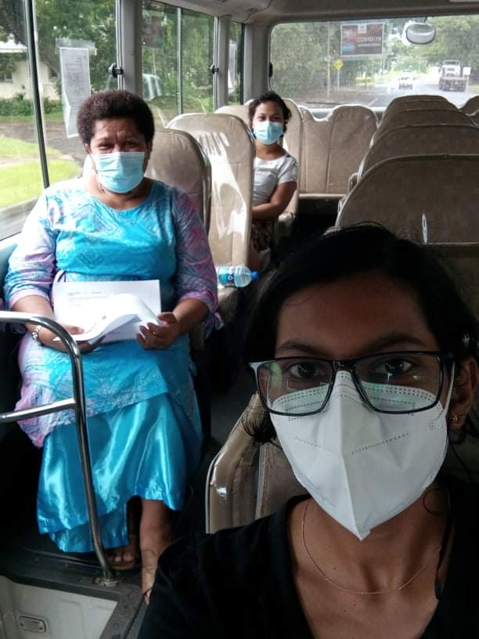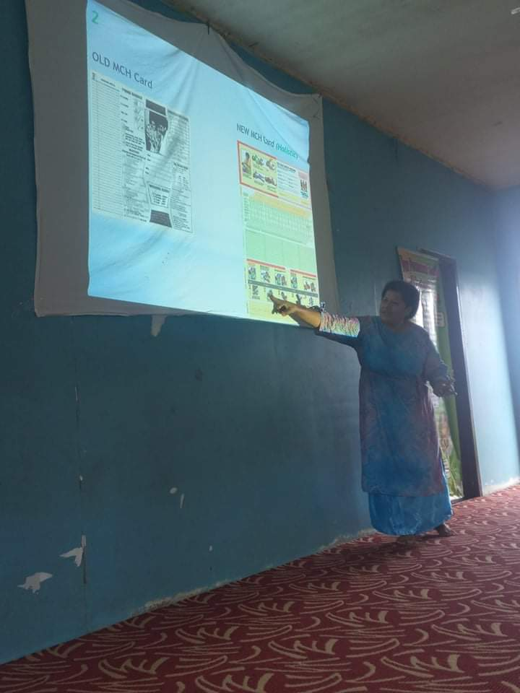
Team on their way to Naviyago village Presentation…
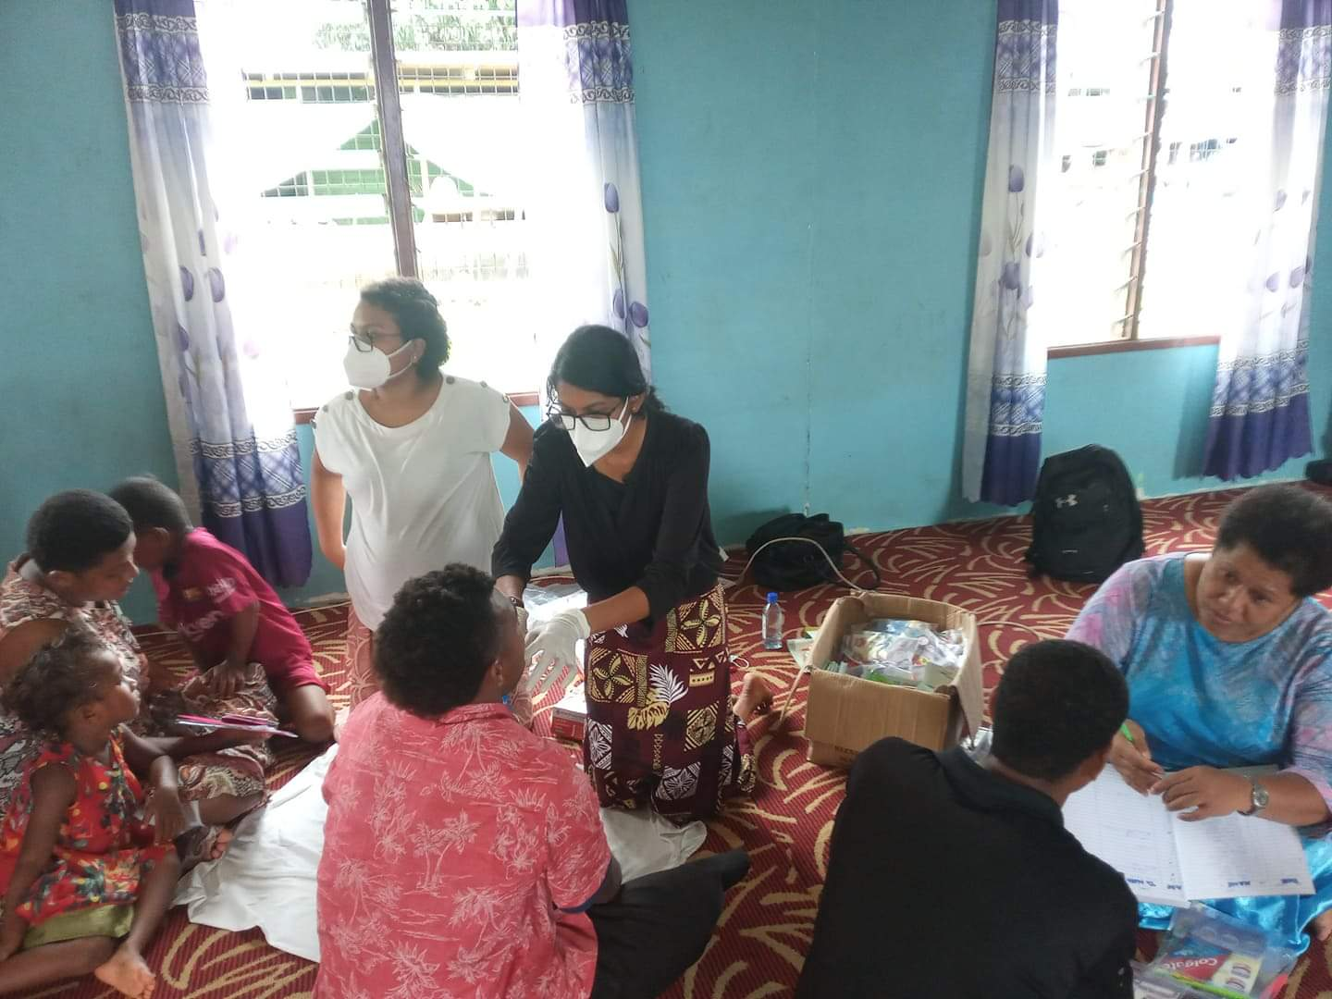 Oral examination and issue of toothbrush packs
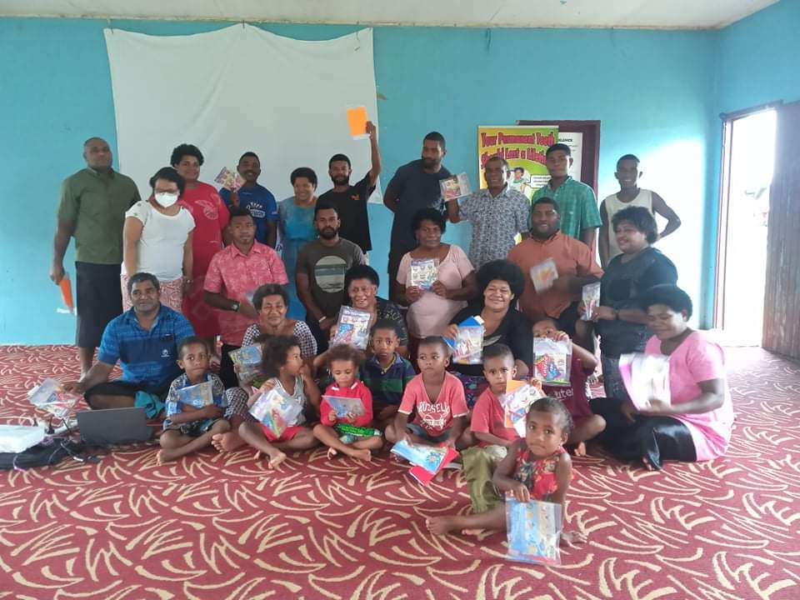 Group photo
Oral Health Promotion Team: Dr Janis, Dr Devashna & IDT Tuiloma

Lovu Hart (24/03/22)
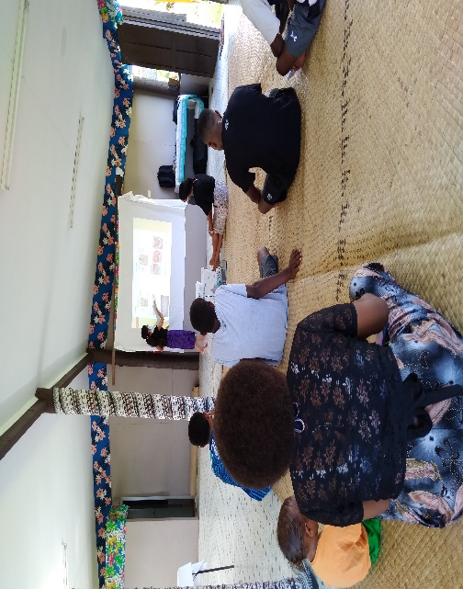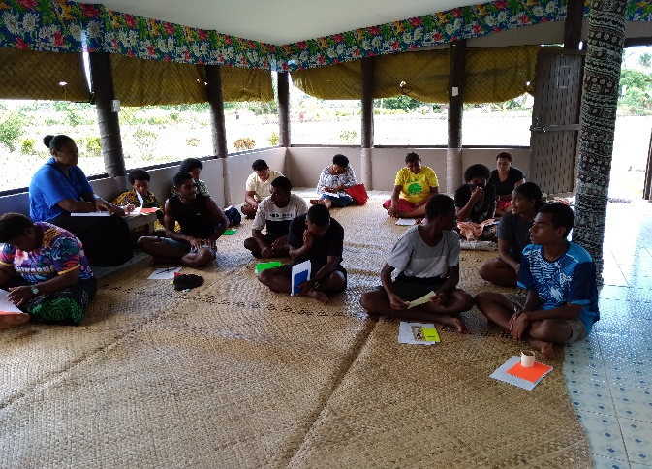
Presentation… Participants…
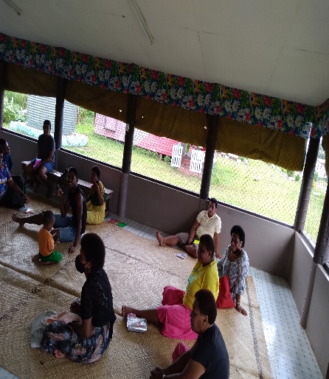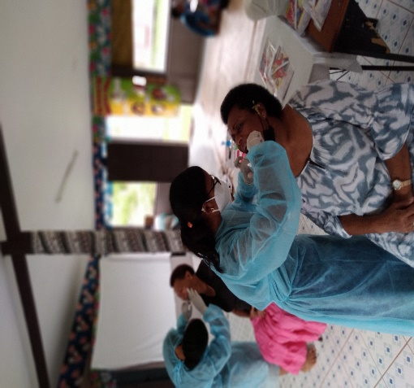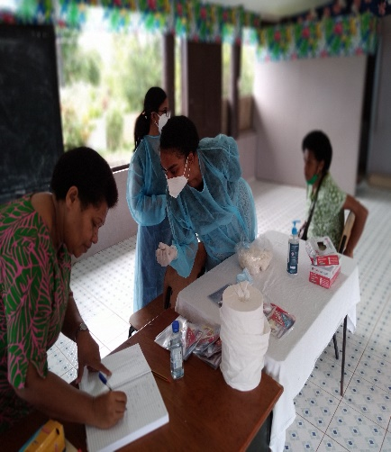
Oral examination… Treatment need recording…
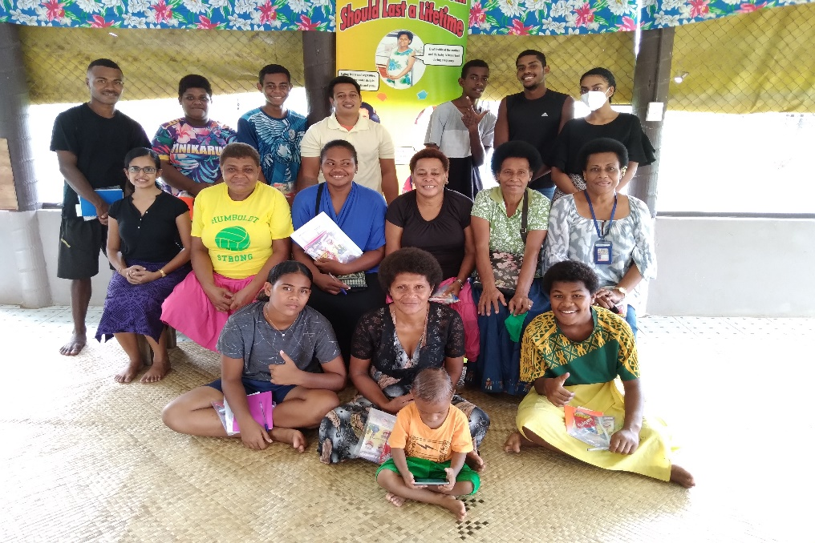 Group photo

Oral Health Promotion Team: Dr Simran, Dr Joy & IDT Tuiloma

Koripita – 24/03/22 (7pm-9pm)
Oral Health awareness and visual checkup
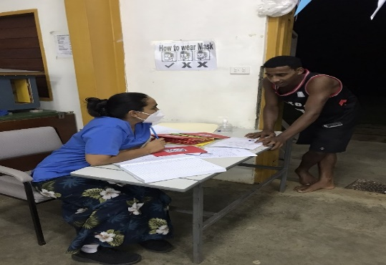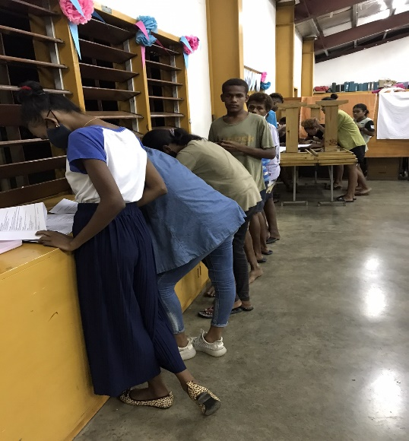
Registration and issue of booklet by Dr Shaista Participants attempting pre knowledge questionnaire
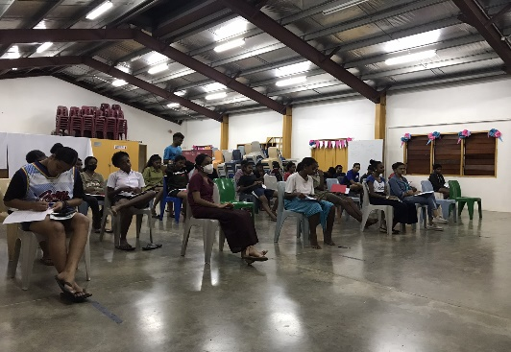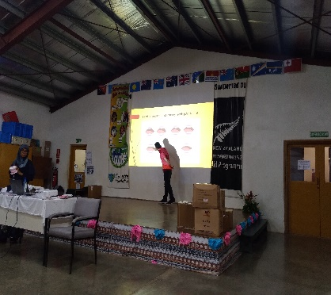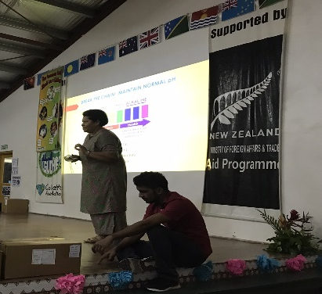
Oral Health awareness participants Presentations…
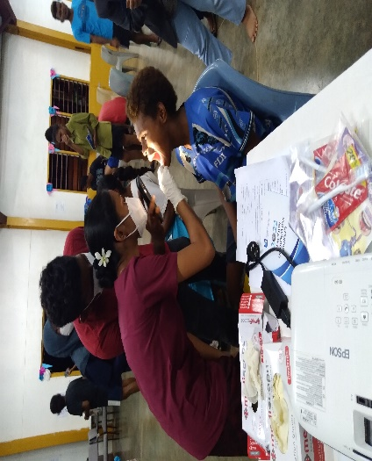 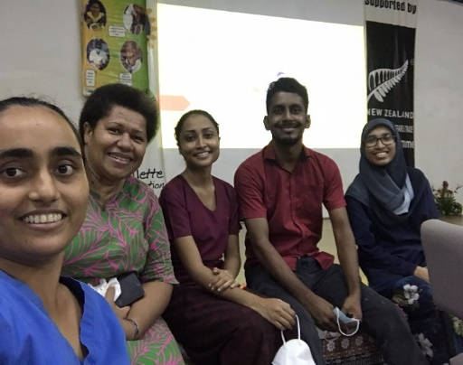 Team to Koroipita:
Visual Examination and Oral Health Instruction Dr Shaista, IDT Tuiloma, Dr Divashna, DH Kritesh and Dr Zaria
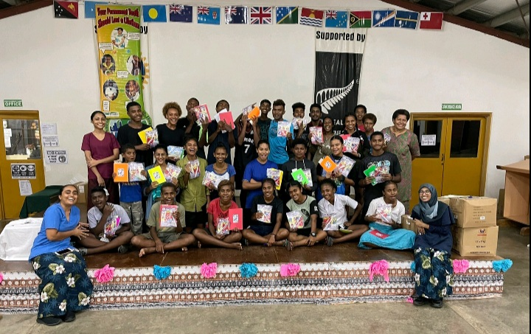 Group Photo
CHALLENGES:
- No standardized procedure for follow up at MCH clinics
- No contact person to coordinate Oral health promotion activities at Public Health level

RECOMMENDATIONS:
- Strengthen the ANC program and MCH at Divisional Hospitals to include Post Natal ward visit before mothers are discharged
- Dental Therapist/ Dental Interns holding Dental Therapist post should be engaged with Oral health promotion activities (Preventive)
- Increase Dental hygienist positions to assist with OHP programs
- Strengthen communication between Hospitals and Public health team to ensure mothers & baby are followed up at health centers to cover the 8 Wellness visits.
- Each Divisional office needs to have an Instructor Dental Therapist to plan, organize Oral Health Promotion activities and liaise with other stakeholders
