BREAK THE CHAIN! MAINTAIN NORMAL pH
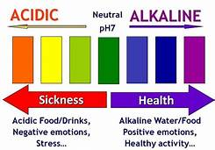
Water 6.5-7.6
Coffee 4.8- 5.1
Sugary drinks 2.5-3.5
Tooth decay 5.5
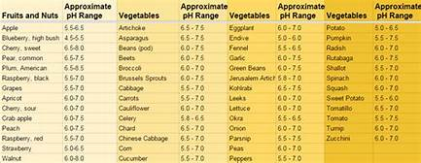
Page 10
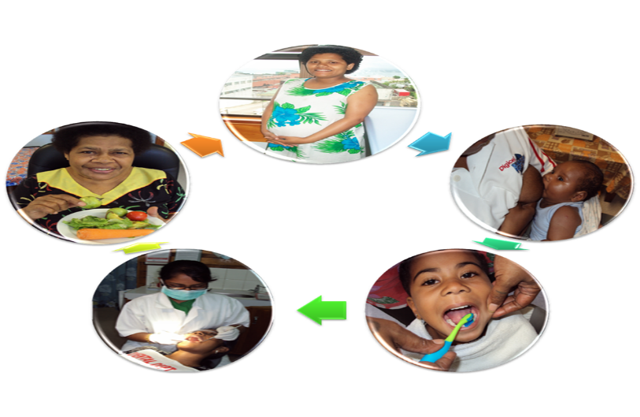
WOMB TO TOMB
Every Stage of life is important

1. From Conception to Birth
2. Baby (birth to 5years)
3. Primary School
4. High School/ Adolescent
5. Adulthood

Page 3

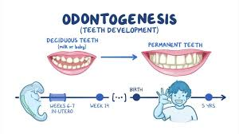
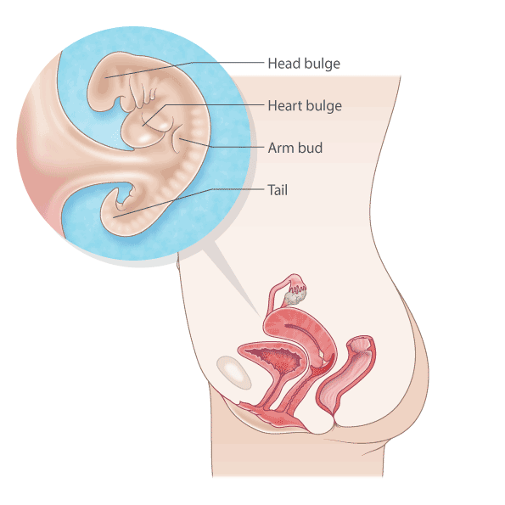
TOOTH DEVELOPMENT:
-Tooth is formed at about the 6th week of pregnancy.
-at 3rd to 4th month of pregnancy the enamel and dentin is formed and root build up.
- The important stages of pregnancy is the first 3months because the head where the brain and mouth is quickly forms.

Page 4

2. FOODS FOR YOUR ORAL HEALTH:
-It is good to choose:
- Natural drinks that does not intoxicate example Fruit punch, coconut juice, water, dairy milk

- Leafy vegetables and lean meat like fish

- Nuts as snacks like raw peanut, almond nuts, warl nuts, ivi, vutu, Guavas, carrot, cucumber etc.
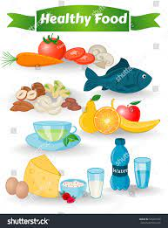

Page 9

“BE PROUD OF YOUR MOUTH FOR HAPPINESS AND WELLBEING”
1. TOOTH BRUSH:
-It is important to choose:
- Soft bristles and the
- size of tooth brush depends on the age…
- from 5months to 8years old small head is recommended and from
- 9years old and above adult size is good.
-Brush your teeth after you eat in the morning and before you sleep at night
-Change your tooth brush every 2-3months or as soon as the
Brush tips bend (worn)

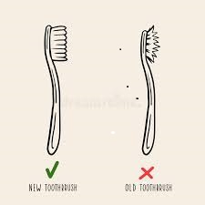
Page 8

CONCEPTION
- Mother’s diet affects tooth development
Enamel is a bone
-proper nutrition helps formation of shallow fissures
-Deep fissures are prone to decay

2. Tooth is development starts in the womb
- Calcification begins (at 6 weeks in utero)
-Root calcification is complete 1–1.5 years after eruption.
3 .Mothers oral hygiene affects new born
(Bacteria triggers hormone which can stimulate pre mature birth and low birth weight)
- Oral examination and necessary treatments are free during pregnancy
- Safe period for treatment is 2nd trimester
(4-6 months)
ANC PROGRAM ‘A SMILE FOR 2’
Page 5

BIRTH TO 5 YEARS: 8 WELLNESS VISITS
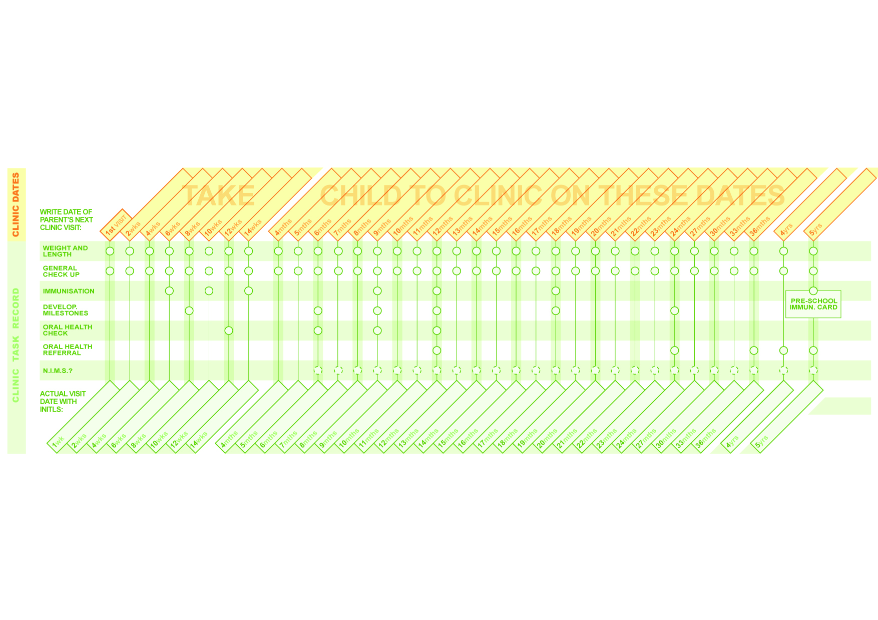
Day 1 to 3 months
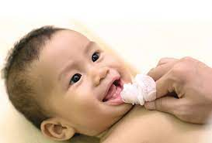
1. Wipe gums and tongue with clean moist cloth after feeding
2. Watch for teething signs (drooling, fever)
3. Exclusive breast feeding
4. First Dental checkup at 3 months

4-6 months
1. First tooth erupt between 4-6 months
2. Wipe gums and tongue with clean cloth after feeding
3. Expect fever during teething. See a doctor if fever is too high or baby has diarrhea
4. Give the child a teaspoon of water before introducing mashed food at 6 months
5. Do not add Sugar or Salt to baby’s food
6. Second Dental checkup at 6 months
Page 6

9 months
1. Wipe gums and tongue with clean cloth after feeding
2. Third Dental visit

1 year
1. Issue 1st toothbrush pack
2. Brush your child’s teeth after every meal
3. Do not use toothpaste
4. Fourth Dental Visit

2-5 years
1 .Supervise child’s brushing after meals
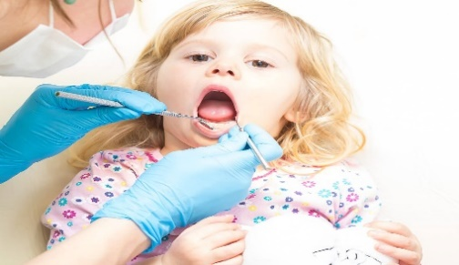
2. Use pea sized toothpaste and wipe excess with clean cloth after brushing
3. 5th-8th Dental visit

PROGRAM
‘HEALTHY 5:20 SMILE’ & ‘MUM YOU FIRST’

Page 7

BE PROUD OF YOUR MOUTH

FOR HAPPINESS AND

WELLBEING

Page 2



3. Be an Example for Pride of Good Oral Health and Well-being:
Healthy Habits is not told, it is lived to reproduce Healthy Well-being.
Adolescents and Adults can make a big difference in children’s lives-now and in the future:
- Teach children healthy choices of food daily. Avoid high sugary foods

- Encourage children to drink water between meals or snacks.

- Reward children with stickers, words of praise or fun activities instead of food.

- Help children brush their teeth with fluoridated tooth paste twice a day. PRAISE them for brushing

Page 11

ABNORMAL
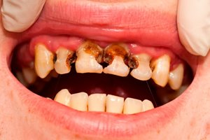
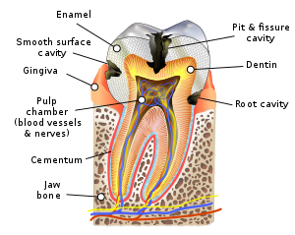
Unhealthy Mouth
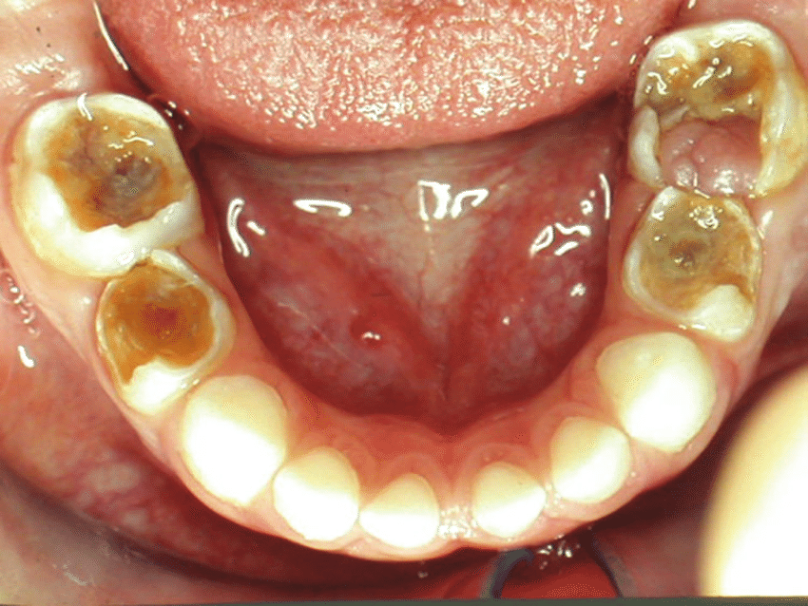

NORMAL+ sugar + bacteria (release acid) + time = ABNORMAL

Page 12

NORMAL
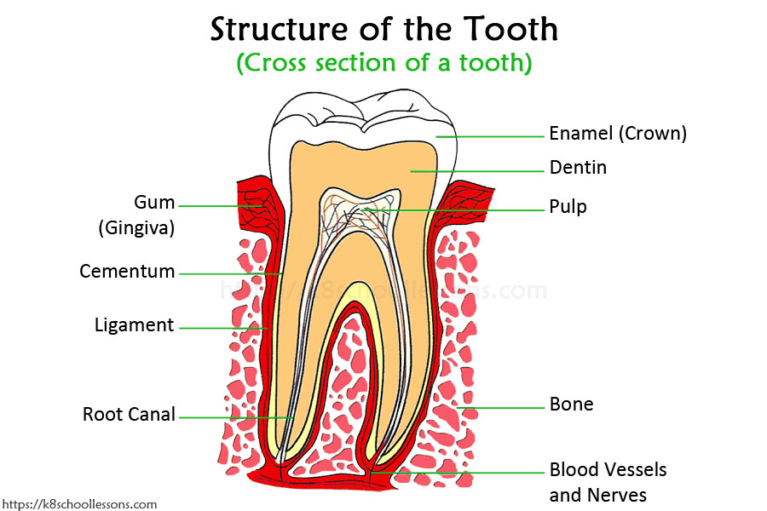
Parts of the Tooth
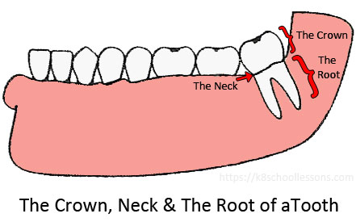

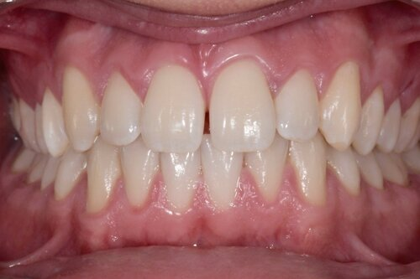
Page 1
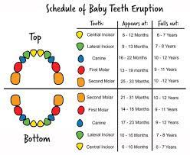

DENTAL CHART RECORD FOR BABY TEETH AND ADULT TEETH
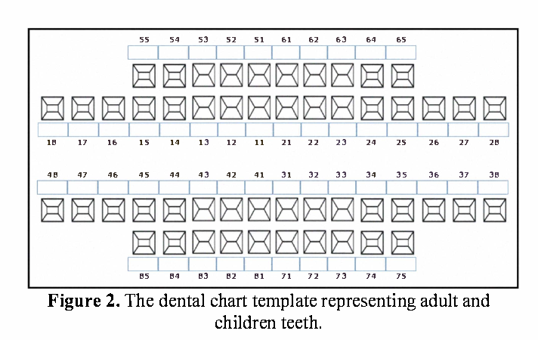

(Inside Hard cover-Back)

(Inside Hard cover-Front)
WELLNESS  DATE | CAREGIVER’S NOTES | CLINICIAN’S NOTES
3months

6months

9months

1 year

2 years

3years

4years

5years

6years > | Continuation of care @primary school level

ORAL HEALTH WELLNESS
BOOKLET
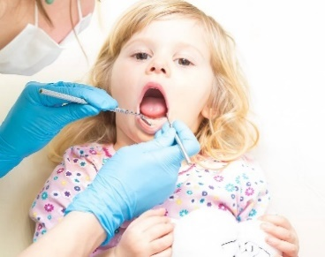

ANTE-NATAL CARE
TO
MATERNAL-CHILD HEALTH CARE

(Outside cover)

